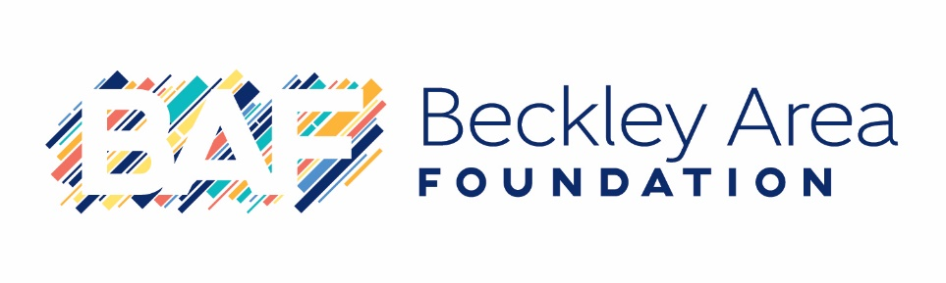
Policy Standards for Scholarship Recipients

- Under no circumstances will a scholarship payment be made if the recipient does not provide a student identification number. Scholarship recipients will provide this number on the acceptance form that is due on June 10.
- Scholarship payments will be made in July of the cycle year. The total amount is divided between the fall and spring semesters. For renewable scholarships, the recipient will not be allowed to have full scholarship payment in one semester because of graduating early. Certificate programs will be paid based on the length of the program.
- If a renewable scholarship recipient graduates early, funds will not be used for graduate studies, unless otherwise stated within the scholarship fund agreement.
- Summer courses will not be covered within scholarship payment. Funds will only be applied to fall and spring semesters during the awarded academic year.
- No scholarship will be held (one-time or renewal) unless extenuating circumstances occur. Recipients can complete and submit the Scholarship Request Form (located on the BAF website) and submit to the Scholarship Coordinator (via email) to be reviewed by the BAF in-house Scholarship Committee. Approval or denial will be sent to the student (via email) within 14 days of the request form submission.
- Students must notify the BAF Scholarship Coordinator when transferring to another school. Deadline for notification is 2 weeks before the start of the semester. Failure to do so will result in forfeiture of the scholarship. Please be aware that schools will not notify BAF of a student transfer, this responsibility of notification rests solely on the scholarship recipient.
- Renewable Scholarship recipients are required to complete the renewal follow-up form (located on the Scholarship Portal) for fall and spring semesters. Failure to complete the renewal form by the given due date will result in forfeiture of the scholarship.
Fall Semester Renewal Follow-Up due January 5
Spring Semester Renewal Follow-Up due May 30
- Renewable Scholarship recipients that complete a certificate program and then decide to reenter another institution for higher degree completion, will need to complete the Scholarship Request Form for approval or denial.

