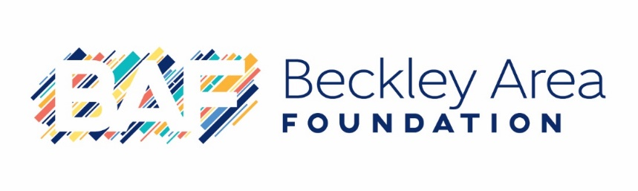
Welcome to the Beckley Area Foundation (BAF) family! In partnering with us by starting a fund, you are joining many others committed to improving their community. The information requested on this form will enable us to serve you better and help ‘tell the story’ of the fund for generations to come. On behalf of our staff and Board of Directors, thank you for choosing BAF to assist you with your philanthropic goals.

Name of Fund: _____________________________________________________________________________

Fund Type: Agency Designated Donor Advised Field of Interest Geographic
Scholarship Unrestricted

Trustee Bank: City National Bank First Community Bank United Bank

Fund Primary Contact Person: ______________________________________________________
Email: ____________________________________________________________________________________
Fund Statements: Would you like to receive fund statements? Yes No
If yes, how often? Annually Quarterly Monthly

Preferred mailing address to receive communication from BAF:

- Home:_______________________________________________________________________
- Work: ________________________________________________________________________

Phone contact information:
Home Phone: __________________ Work Phone: __________________ Cell Phone: __________________

Fund Purpose and Information:
Please tell us about the purpose of the fund (who it benefits and desired impact) and any personal reason for creating it (attach a separate document if preferred):

If the fund is in honor or memory of someone, tell us more about the person(s), including history (born and raised), education, profession, family, love for the community, mission in life, interests, hobbies, awards, community service (attach a separate document if preferred):

Is there any additional information that you would like to add?

Please email a photo and quote for BAF to use in the press release to samuel@bafwv.org.

Future Fund Development
Do you plan to contribute additional gifts to this fund?
- Yes
- No
- I would like someone to contact me about this.

Elaborate if you wish:

Is BAF and/or the fund in your estate plan?
- Yes
- No
- I would like someone to contact me about this.

Elaborate if you wish:

If desired, please list your professional advisor:

If desired, please list your attorney, accountant, or any other advisors you would like BAF to be aware of:

